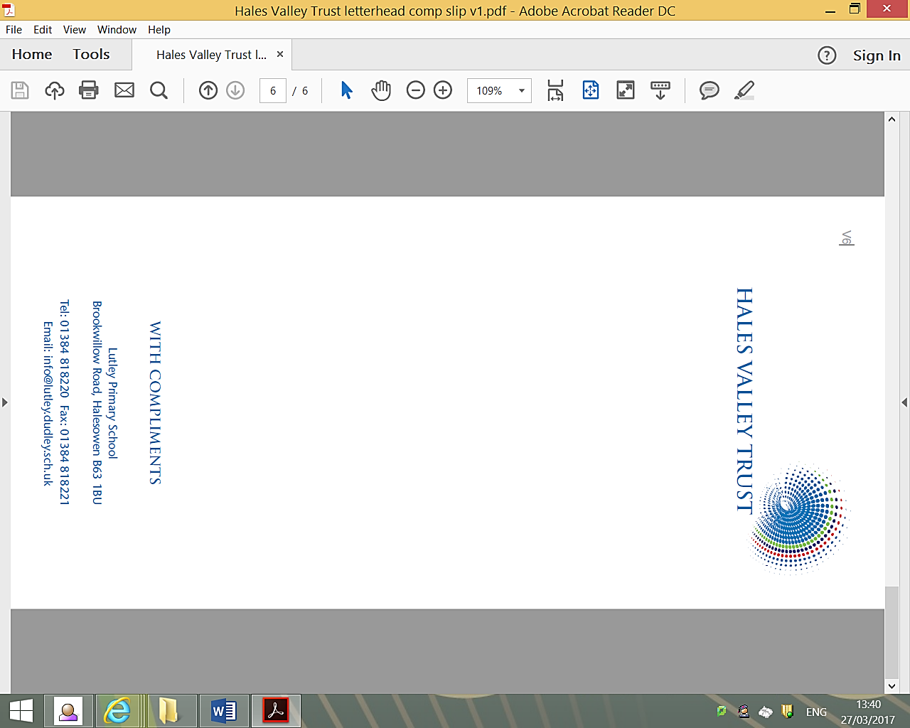

Google Classrooms Technical Support

It has come to our attention that some are having difficulty accessing Google Classrooms due to having personal email addresses getting mixed up when trying to access it. We have sought technical advice and they have responded with:

The easiest way around this issue is for them to open the web browser using *incognito mode* or *inPrivate* browsing. This will not remember any previous sessions and will allow you to have personal emails open, while also signed into Google Classroom using a school email address in another window.
To access this you can:
In Internet Explorer: press *ctrl + Shift + P*
In Google Chrome: Press *ctrl + Shift + N* or click on the 3 vertical dots in the top right, then click *New incognito window* button
In Edge: Press *ctrl + Shift + P* or click on the 3 horizontal dots in the top right, then click *New InPrivate window* button

At present we have 52 children accessing Google Classrooms. Thank you for such a fast response to a great resource.

Stay Safe! Stay Health!

K Burns

Mrs K Burns
Deputy Headteacher

