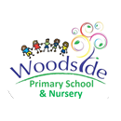
The Orchard Curriculum Newsletter – Summer Term 2025

Welcome back! We hope you are ready for the Summer Term after a lovely Easter break. This half term we are exploring life cycles and healthy eating through the story ‘The Very Hungry Caterpillar’. After half term, we shall be looking at different modes of transport, road safety and light, sound and colour. As always, we appreciate all of the support you provide at home and look forward to working with you to help your children progress further with their learning.
The Orchard Team
The Orchard Leader: Mrs Walford
Teacher: Miss Guest
Support staff: Miss Noons, Mrs Hodgetts, Miss Lloyd
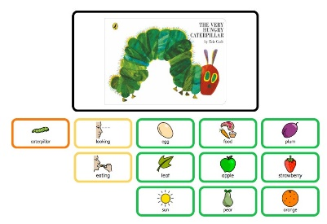
English
We will be sharing this story with the pupils through a sensory approach. Allowing all pupils to access our story. Once the children are familiar with our story we shall start exploring who are the main characters using colourful semantics. The pupils will explore mark making in paint, sand and foam all linked to ‘The Very Hungry Caterpillar’
Phonics
We will continue to deliver 1:1 phonic session for all pupils using the Little Wandle phonics programme. As well as this, the pupils will receive daily rhyme time where the pupils will experience different nursery rhymes.
This term we are looking at:
- Row, row, row your boat.
- Wind the Bobbin’ up
- Down at the Station
- The Wheels on the Bus
- A Sailor went to Sea
Maths
We will continue to explore number 0-10. Sharing different representations of these numbers. This will be done through various songs and resources linked to the individual pupil delivered 1:1.

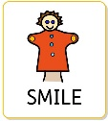  Persona, Social and Health Education  The pupils will explore the different between healthy and non-healthy food items. The pupils will be able to explore the taste and texture of different foods through our ‘see it, smell it, touch it, taste it’ approach.  After half term, the pupils will learn hoe to cross the road safely and always staying close to an adult. | 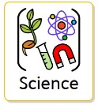  Science  Using sensory stories, we shall be learning about two different life cycles. Life cycle of a plant and life cycle of an animal. After half term we shall be exploring different sounds and lights using different sensory objects. We will then match the sound and light to different objects of reference.  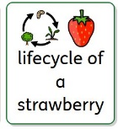  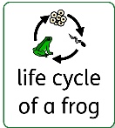  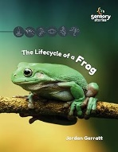  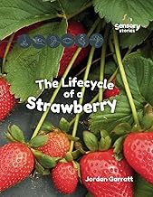
DT  The pupils we be exploring the different fruit that the caterpillar discovers in ‘The Very Hungry Caterpillar’. The pupils will then plan and make their own fruit skewer that they can then eat.  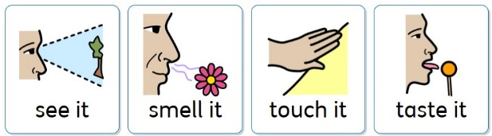 | 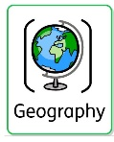  Geography  This half term, the pupils will be exploring hot and cold places. This will be delivered through sensory stories and allowing the pupils to touch and feel hot and cold objects. At the end of the half term, the pupils will investigate different animals and if they live in a hot or cold climate.

Bucket Time
Attention building activities linked to fine-motor activities. These activities will be linked to the book that we are delivering.
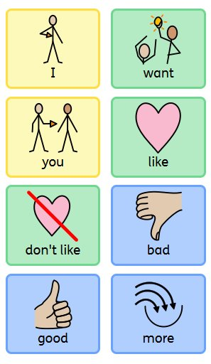
I am aware that many parents are exploring different ways for your child to communicate with you. Below is an Aided Language Display. This is something we are using for the children to share if they like or dislike something they have touched. If you have an Augmentative and Alternative Communication (AAC) you may wish to ass these core words. If you do not, please use this to model language at home.

