Personal, Social, Health and Economic Education (PSHE) Policy
including Relationships, Sex and Health Education (RSHE)

Date | Review date | Authors | Reviewed by | Date approved/ received by the Local Governing Committee
September 2024 | September 2025 | Kerry Burns  Hollie Jennings | Sally Bloomer | September 2024
September 2025 | September 2026 | Eleanor Harvey | Hannah Pickles | September 2025
September 2026 | September 2027 | Eleanor Harvey | Claire Johnson | October 2026

Personal, Social, Health and Economic Education (PSHE) is our comprehensive curriculum for supporting children's personal development, health, wellbeing and understanding of relationships.

We are required by law to teach Relationships Education and Health Education to all primary-aged pupils. We deliver these statutory subjects within our broader PSHE programme. Where we teach about human reproduction (sex education), we do so in line with the principles and approach of the 2025 Relationships, Sex and Health Education (RSHE) statutory guidance, in which sex education itself remains non-statutory (but recommended) in primary schools.

Our PSHE curriculum also includes age-appropriate aspects of economic education, preparing children to understand spending, saving and the world of work, and citizenship education including British Values, helping children understand their rights, responsibilities and role in society.

This policy explains our whole-school approach to PSHE education and how we meet our statutory duties.

1. Our Vision for PSHE Education

At Hales Valley Trust and Woodside, we believe every child deserves an education that prepares them not only for academic success but also to thrive as rounded individuals in modern society. Personal, Social, Health and Economic (PSHE) education sits at the heart of this commitment.

PSHE is not an add-on to our curriculum; it is fundamental to our children’s development as confident, healthy and respectful members of society. Through high-quality PSHE, we equip pupils with the knowledge, skills and attributes they need to stay safe, maintain wellbeing, and build positive relationships throughout their lives.

Our curriculum is carefully designed to be developmental and progressive. From the moment children join our school, they begin to explore emotional literacy—learning to recognise, name and talk about feelings. This foundation grows year by year, helping pupils to manage emotions, develop resilience, and make informed decisions that support their own and others’ wellbeing.

By embedding PSHE across our school culture, we nurture a community where respect, inclusivity and responsibility flourish. In doing so, we prepare our pupils not only for the challenges of childhood but also for adulthood, work and active citizenship.

At Woodside Primary School, personal wellbeing underpins all aspects of learning. We aim to develop confident, resilient and respectful pupils who understand how to keep themselves safe and build healthy relationships and contribute positively to their community.

We are committed to:
- Supporting the whole child - recognising that children's emotional and social development directly impacts their capacity to learn
- Creating a safe, inclusive environment where every child feels valued and able to discuss concerns without fear or stigma
- Building foundations for the future - providing age-appropriate learning that prepares children for the challenges and opportunities of adolescence and beyond
- Working in partnership with families, recognising that parents are children's first educators in many aspects of relationships and health
- Embedding PSHE across school life - not just in weekly lessons, but through our values, relationships, and everyday interactions

2. Statutory Requirements and Curriculum Framework

Under the Education Act 2002 and the Academies Act 2010, all schools must provide a curriculum that:

- Promotes the spiritual, moral, cultural, mental and physical development of pupils
- Prepares pupils for the opportunities, responsibilities and experiences of later life

The Relationships Education, Relationships and Sex Education and Health Education (England) Regulations (updated July 2025) make Relationships Education and Health Education statutory for all primary-aged pupils. These subjects must be taught in all maintained schools, academies, independent schools, maintained special schools, non-maintained special schools, and alternative provision settings.

We deliver statutory Relationships and Health Education within our comprehensive PSHE programme, using materials from Jigsaw PSHE 3-11. This provides children with a carefully sequenced, age-appropriate curriculum that meets all statutory requirements whilst also developing wider personal and social capabilities. Our PSHE curriculum also supports our safeguarding responsibilities as set out in Keeping Children Safe in Education and the Prevent Duty, helping children to recognise concerns, stay safe online and offline, and seek help when needed.
Our curriculum addresses all statutory requirements including:

- Families and people who care for me
- Caring friendships
- Respectful, kind relationships
- Online safety and awareness
- Being safe
- Mental wellbeing
- Internet safety and harms
- Physical health and fitness
- Healthy eating
- Drugs, alcohol, tobacco and vaping
- Health protection and prevention
- Basic first aid
- Developing bodies (including puberty as part of Health Education)

A detailed mapping document showing how the Jigsaw programme covers every statutory outcome is available to view on request and can be accessed via appendix A.

3. The Jigsaw Approach: A Whole-School Framework

We use Jigsaw PSHE as our curriculum framework because it provides a comprehensive, carefully sequenced scheme of work that brings consistency and progression to children's learning across their primary years. Built on current research and best practice in child development, safeguarding and health education, it is kept continuously up to date with evolving statutory guidance and enables us to deliver high-quality PSHE education that meets our children's needs. The programme is distinctive in its approach including:

Emotional literacy at the core - Every Jigsaw lesson systematically develops children's emotional vocabulary and understanding. Children learn to recognise, name and talk about a wide range of feelings in themselves and others. This emotional literacy supports children's ability to share and discuss things that are important in their lives, to seek help when needed, and to build positive relationships.

Mindful practice - Every Jigsaw lesson begins with 'Calm Me Time', a mindfulness activity designed to support self-regulation and create a safe, focused space for learning. This consistent practice forms part of our approach to children's emotional wellbeing and helps children to be ready for open, thoughtful discussion.

Connection and community - The 'Connect Us' activity in every lesson strengthens relationships within the class and develops children's social skills, building a sense of belonging and mutual respect that underpins all learning.

Developing skills for respectful dialogue - PSHE lessons provide regular opportunities for children to develop and practise essential communication skills including listening to others, expressing their own views clearly and respectfully, considering different perspectives, and engaging in constructive discussion. These oracy skills are fundamental to building positive relationships and respectful communities, enabling children to navigate differences with kindness and to participate confidently in democratic discussion.

Age-appropriate spiral curriculum - Topics are revisited across year groups with increasing depth and complexity, enabling children to build on prior learning in line with their developing maturity and understanding, with teachers able to adapt according to their pupils’ needs.

Interactive, participative teaching - Lessons are designed to be engaging and active, using discussion, role-play, problem-solving and creative activities to develop skills alongside knowledge. Children don't just gain information - they explore topics in age-appropriate ways and develop practical skills that support them in their everyday lives.

The Six Jigsaw Puzzles
Our PSHE curriculum is organised into six themed units ('Puzzles'), each taught for approximately half a term:

Term | Puzzle | Key Content
Autumn 1 | Being Me in My World | Understanding personal identity, my place in the class and school community, rights and responsibilities, democracy, making a positive contribution.
Autumn 2 | Celebrating Difference | Recognising and respecting diversity, challenging stereotypes, understanding difference and similarity, addressing bullying, building empathy and compassion.
Spring 1 | Dreams and Goals | Setting and working towards goals, understanding aspirations and future possibilities, developing perseverance and resilience, recognising achievements, working collaboratively.
Spring 2 | Healthy Me | The relationship between physical and emotional health; nutrition, sleep, exercise and hygiene; emotional wellbeing; drug education (including medicines); keeping safe; understanding habits and making healthy lifestyle choices.
Summer 1 | Relationships | Understanding different relationships and their characteristics, our families, managing friendship challenges, conflict resolution and communication skills, recognising when relationships are unhealthy, understanding loss and bereavement.
Summer 2 | Changing Me | Understanding life cycles and human growth, coping positively with change, body image and self-esteem, puberty education, changing relationships, and for upper Key Stage 2, human reproduction (where taught as sex education - see Section 6).

Adapting Jigsaw for Our School Community
Whilst we follow the Jigsaw programme, we recognise that our children, families and context have specific needs and characteristics. Our PSHE lead and class teachers carefully consider each lesson's content and approach to ensure it is appropriate and relevant for our pupils, considering:

- The specific needs, experiences and developmental stages of pupils in each class
- Pupil voice - gathered through feedback within lessons, informal discussions with children as well as school council, pupil questionnaires, safeguarding reviews and regular feedback within lessons.
- Local context and community considerations
- Feedback from parents, pupils and staff
- Our school's distinctive values and ethos
- Meeting the needs of pupils with SEND, EAL, disadvantaged pupils and vulnerable learners

Where we make adaptations to the programme, these decisions are made thoughtfully, in consultation with senior leadership, and with reference to statutory requirements. Parents and carers are informed about significant adaptations, particularly where these relate to sensitive content.

4. Curriculum Time and Whole-School Approach

PSHE is taught weekly through dedicated curriculum time of 45 minutes per week by their class teachers. Learning is integrated naturally into the classroom environment so that teachers can draw connections between PSHE and other areas of learning. As well as linking to assemblies, days of celebration, wider curriculum opportunities and whole school events. A sample of resources can be found in appendix B.

Beyond the Classroom: Embedding PSHE in School Life
We recognise that effective PSHE education extends far beyond weekly lessons. The skills, values and understanding developed in PSHE sessions are reinforced and 'lived' throughout our school day and across all areas of school life such as:
- Collective worship and assemblies regularly explore PSHE themes, celebrating successes, exploring moral questions, and building whole-school awareness of current wellbeing and relationship topics.
- Our behaviour and relationships policy reflects the principles taught in PSHE, emphasising respect, kindness, responsibility and positive conflict resolution. Adults model these values in all interactions with children and each other.
- The Jigsaw Learning Charter established in each class at the start of the year becomes a living document that children refer to and use to guide behaviour and resolve difficulties.
- Playground and social times provide opportunities for children to practise the friendship and conflict-resolution skills learned in PSHE, supported by staff who understand the PSHE curriculum and can reference learning when supporting children.
- Emotional literacy taught in PSHE develops an extensive vocabulary for feelings and emotions which is reinforced throughout the school day, with staff supporting children to name and express their feelings, to understand others' emotions, and to use this awareness to build positive relationships and resolve difficulties. Display materials, including calm corners which display zones of regulation, calming objects as well as feeling vocabulary are shown to support learners.
- Recognition and reward systems celebrate not just academic achievement but the personal and social qualities developed through PSHE - kindness, perseverance, respect, courage, and contribution to the school community. At Woodside we have ‘Wonder of Woodside’ awards as well as ‘Hot Chocolate Heros’.
- Our learning environment reflects PSHE values, with working walls displaying current learning, vocabulary walls supporting emotional literacy, and visual prompts reinforcing key concepts like the Jigsaw Charter, feelings vocabulary, and strategies for wellbeing.

Learning Outdoors: Connecting PSHE to Our Environment
“Schools should emphasise the relationships between physical health and mental wellbeing, and the benefits of physical activity and time spent outdoors.”
DfE RSHE Guidance 2025, para 40

We use our school grounds and local outdoor spaces to enhance PSHE learning, providing opportunities for children to experience the wellbeing benefits of time in nature, to develop environmental awareness, and to apply their learning in varied contexts.
Teachers plan regular opportunities to take PSHE learning outside where appropriate, and we encourage children to spend time outdoors during breaks and lunchtimes, recognising that unstructured outdoor play supports emotional regulation, creativity, and relationship-building.

At our school, lunchtimes are supported through the OPAL (Outdoor Play and Learning) approach, which recognises play as a vital part of children's personal, social and emotional development. OPAL provides children with opportunities for self-directed, inclusive and creative play within a safe and stimulating environment. Through a range of outdoor experiences, children develop cooperation, communication, resilience, problem-solving skills and positive relationships with others. The OPAL programme supports the aims of PSHE and RSHE by promoting respect, teamwork, emotional wellbeing, risk awareness, independence and responsible decision-making, helping pupils to build the skills and confidence needed for healthy relationships and active participation in school life.

5. Relationships and Health Education: Statutory Content

Relationships Education
Relationships Education is compulsory for all primary-aged children and there is no right of withdrawal. It focuses on teaching children the fundamental building blocks of positive, respectful relationships with family, friends, peers and adults.

By the end of primary school, our children will understand:
- Families and people who care for me - That families come in many forms, and all can provide love, security and stability; the characteristics of healthy family life; how to recognise unhealthy family relationships and seek help; marriage and civil partnerships as legal commitments.
- Caring friendships - How friendships contribute to happiness and security; characteristics of healthy friendships including mutual respect, trust, loyalty and kindness; how to recognise and navigate friendship difficulties; how to make and maintain positive friendships.
- Respectful, kind relationships - The importance of paying attention to others' needs; setting and respecting boundaries; communicating effectively and managing conflict with kindness; the importance of respect and self-respect; different types of bullying and how to respond; understanding stereotypes and how to challenge them.
- Online safety and awareness - How to behave respectfully online; critically evaluating online relationships and information; understanding privacy and personal information; recognising and reporting online risks; age restrictions for social media; understanding that content online can be inappropriate or upsetting.
- Being safe - Understanding appropriate and inappropriate boundaries; concepts of privacy and consent; that each person's body belongs to them; how to recognise when relationships are unsafe; how to respond to concerning adults; how to report abuse and seek help with confidence.

Health Education
Health Education is compulsory for all primary-aged children and there is no right of withdrawal. It focuses on supporting children to make informed decisions about their health and wellbeing.

By the end of primary school, our children will understand:
- Mental wellbeing - The normal range of emotions; how to recognise, talk about and manage feelings; simple self-care techniques; that mental health challenges are common and can be supported; where and how to seek help when needed.
- Internet safety and harms - The benefits and risks of internet use; rationing screen time; recognising and displaying respectful online behaviour; age restrictions on games and apps; being discerning about online information; where to report concerns.
- Physical health and fitness - Benefits of an active lifestyle; building regular physical activity into routines; risks of inactive lifestyles; when to seek health support.
- Healthy eating - What constitutes a healthy diet; principles of healthy meal planning; risks of unhealthy eating including impacts on teeth and weight; impacts of alcohol on health.
- Drugs, alcohol, tobacco and vaping - Age-appropriate facts about legal and illegal substances and associated risks, including the risks of nicotine addiction.
- Health protection and prevention - Recognising early signs of illness; sun safety; importance of good quality sleep; dental health and oral hygiene; personal hygiene and germ spread; facts about vaccination and immunisation.
- Personal safety - Recognising hazards and reducing risks; road, water and rail safety; when and how to seek help in emergencies.
- Basic first aid - How to make emergency calls; dealing with common injuries including head injuries.
- Developing bodies - Understanding growth and body changes during adolescence; correct names for body parts; facts about the menstrual cycle including physical and emotional changes (noting that whilst average age of menstruation is 12, it can begin from age 8, so we teach this content before girls experience menstruation).

Building Foundations for Secondary RSHE
The primary PSHE curriculum is carefully designed to be age-appropriate and valuable for children's current stage of development. This learning also builds strong foundations that will support children as they encounter more complex content at secondary school. For example:

- Children learn skills for managing difficult feelings in friendships like disappointment or anger. These are essential skills for their current friendships and family relationships and support them to behave with kindness as their relationships become more complex.
- Children learn about appropriate boundaries, privacy and consent in age-appropriate ways from early primary. This learning is crucial for safeguarding - enabling children to recognise when something doesn't feel right, to understand that they have rights over their own bodies and personal information, and to seek help when needed. These concepts become increasingly important as children develop and encounter different situations, both now and in future relationships.
- We teach children to recognise healthy relationship characteristics and warning signs across all relationships. This helps them navigate their current friendships and family relationships, with skills they'll continue to apply throughout their lives.
- Understanding of online safety, digital literacy and respectful online behaviour builds progressively throughout primary. We recognise that some of our children are already spending time online, and those who are not will have questions or concerns about the online world. Our approach is preventative, equipping children with knowledge and skills to stay safe if they do encounter online content or situations, rather than normalising excessive or unsafe internet use. This prepares children to navigate the more complex digital relationships and challenges they'll encounter as teenagers.
- Learning about emotions, mental wellbeing and self-care begins early and deepens each year. This supports children's current wellbeing and helps them manage the everyday challenges of childhood, whilst ensuring they reach secondary with established vocabulary, awareness and strategies for protecting their mental health.

This progressive, developmental approach ensures that PSHE content is always age-appropriate and relevant to children's current lives, whilst also building solid foundations for more sophisticated understanding as they mature.

Challenging Stereotypes and Promoting Respect
Throughout our PSHE curriculum, we actively work to break down harmful stereotypes, including gender stereotypes that can limit children's aspirations, reinforce inequalities, or contribute to disrespectful behaviour, and explain how some characteristics are protected under UK law. As children progress through the programme, they encounter a number of protected characteristics in age-appropriate ways, understanding why certain groups have legal protection from discrimination and how this relates to treating all people with dignity and respect.

For example, children learn that all people deserve respect regardless of their sex, and we challenge outdated ideas about what boys and girls "should" be like, what they can achieve, or how they should behave. We help children understand that boys and girls can have diverse interests, strengths, and personalities, and that qualities like kindness, strength, nurturing, and courage are human qualities that everyone can demonstrate, not traits that belong only to one sex.

Age-appropriately, we address how stereotypes and prejudiced attitudes, including misogyny, can lead to unkind behaviour, bullying, and a lack of respect in relationships. We make clear that everyone - boys and girls - has responsibility for treating others with kindness and respect, and that harmful attitudes or language are never acceptable.

This approach supports both safeguarding and the development of healthy, equal relationships, helping all children to feel valued and to respect others.

6. Sex Education at Woodside Primary School

Sex education is not compulsory in primary schools, however the Department for Education recommends that all primary schools teach age-appropriate sex education to ensure children are prepared for the change’s adolescence brings and understand how human life begins.

At Woodside our approach to sex education is:

Sex Education as part of PSHE (subject to parental withdrawal)

We teach age-appropriate sex education in Years 5 and 6 as part of our PSHE curriculum, going beyond the statutory content about puberty to include factual information about human reproduction. We believe this information is important for children before they leave primary school, particularly as children naturally become more aware and curious about how life begins and may seek information from less reliable sources if we do not provide age-appropriate, factual teaching.

We define sex education as learning about human reproduction. It is defined as those lessons covering sexual intercourse, conception, the stages of pregnancy and birth. It includes the emotional impact of having a baby as well as the physical facts. Sex education is not learning about different types of sexual activity.

This is distinct from the statutory Health Education content about puberty and menstruation, and from Science curriculum content about life cycles and reproduction in mammals, from which children cannot be withdrawn.

The following Jigsaw lessons in the Changing Me Puzzle contain non-statutory sex education content:

Year 5: Conception
Year 6: Babies: Conception to Birth

Parent Engagement and the Right to Withdraw from Sex Education
Parents have the right to request that their child be withdrawn from some or all of sex education taught as part of PSHE. Parents do NOT have the right to withdraw children from:

- Relationships Education (statutory)
- Health Education, including puberty education (statutory)
- Science curriculum content, including content about reproduction (statutory)

Before making a decision to withdraw a child from sex education, we invite parents to discuss their concerns with their class teacher and PSHE lead. This discussion helps us to understand the request and enables us to clarify the nature and purpose of the curriculum, discuss the benefits of the education, and consider any potential impacts of withdrawal on the child.

Where a parent requests withdrawal, we will:
- Arrange a meeting to discuss the request and the curriculum content in detail
- Share relevant teaching materials so parents can see exactly what will be taught
- Explain how we will support the child during withdrawal (ensuring they receive appropriate, purposeful education)
- Respect the parent's final decision whilst documenting our professional advice

We inform parents about sex education content by sending curriculum information letters at the start of the summer term, holding parent information sessions, and making all materials available for viewing on request.

A withdrawal request form is available from class teacher, school office and appendix C of this policy.

Sex Education taught within science (no right of withdrawal)
We teach about human reproduction within our science curriculum, in line with the National Curriculum Science requirements that children learn about life cycles and how mammals reproduce. Due to this being taught as part of the statutory Science curriculum, parents do not have the right to withdraw children from this content. We ensure this learning is delivered in a factual, scientific manner and is age-appropriate.

Responding to children's questions
We recognise that children may ask questions beyond our planned curriculum. Teachers use professional judgement to respond and may answer briefly and factually if age-appropriate, suggest the child speaks with their parent or carer, or acknowledge the question while explaining they'll learn more when older.

If a withdrawn child asks questions about sex education content, teachers will sensitively explain this is something their parents would like to discuss at home. We will inform parents so they can follow up.

7. Inclusive Practice and Equality
We are committed to an inclusive PSHE curriculum that is accessible to and respectful of all children and families.

Meeting the Equality Act 2010
We comply with the Equality Act 2010 and the Public Sector Equality Duty, ensuring that PSHE is taught in a way that:

- Does not subject pupils to discrimination
- Promotes equality of opportunity
- Fosters good relations between people with protected characteristics and those without

The protected characteristics are age, disability, gender reassignment, marriage or civil partnership, pregnancy and maternity, race, religion or belief, sex, and sexual orientation.

Teaching about Families and Relationships
Our curriculum presents families in all their forms, recognising that children come from diverse family backgrounds including:

- Single parent families
- Same-sex parent families
- Families headed by grandparents or other relatives
- Adoptive families
- Foster families
- Kinship care arrangements
- Blended families
- Families from different cultural and religious backgrounds
- Service families, including those where a parent or carer serves in the armed forces

We ensure that no child is stigmatised based on their home circumstances and that all family structures are represented positively in our teaching. When discussing families, we emphasise that the key characteristic of families is that they provide love, care, stability and security for children, not a particular structure.

Including LGBT Content
Throughout PSHE education, children learn that all people deserve to be treated with respect and kindness, regardless of difference. This is a fundamental principle that runs through all our teaching.
In teaching about families and relationships, we include same-sex parents alongside other family structures, presented naturally as one of the many different types of families that children may have or encounter. This content is integrated throughout the curriculum rather than taught as a standalone topic, ensuring that diverse families are visible and valued within our school community.
Children learn about treating others with kindness and respect, understanding that people have protection from discrimination and should be treated with dignity and respect, and that there are laws in place to protect people’s rights. Pupils learn how bullying or discriminatory behaviour is never acceptable and how to report this for themselves or others.

Jigsaw PSHE 3-11 does not include content on gender questioning or transgender topics. Our focus at primary level is on teaching children to respect all people and to challenge stereotypes about what boys and girls can do, be, or achieve, without introducing complex concepts about gender identity.

Supporting Children with SEND
Children with special educational needs and/or disabilities receive appropriate, adapted PSHE education that meets their needs. PSHE is particularly important for children with SEND, who may be more vulnerable to exploitation, abuse and bullying. Teachers adapt lessons to ensure content is accessible, using:

- Visual supports, simplified language, concrete examples
- Additional pre-teaching or small group work where needed
- Multi-sensory approaches and practical activities
- Extended time for processing and responding
- Personalised social stories or resources where appropriate

For some children with SEND, certain PSHE content may need to be taught in different ways or at different times to ensure understanding and safety. The SENCO works closely with the PSHE lead and class teachers to ensure appropriate provision.

Respecting Religion and Belief
We respect the religious backgrounds and beliefs of all families in our school community. PSHE content is delivered in a factual, objective manner, presenting scientific and medical information accurately whilst being sensitive to diverse religious perspectives.

Where relevant, we may discuss different views held by religious communities on issues, helping children to understand that people's beliefs inform their values and choices. This is done in a way that promotes respect for diversity of belief whilst being clear about the law and children's rights.

8. Safeguarding and Support

PSHE education has a crucial role in our safeguarding provision, equipping children with the knowledge and skills to keep themselves safe and to seek help when needed.
Through PSHE, children learn to:

- Recognise when relationships or situations are unsafe
- Understand that abuse is never their fault
- Know a range of trusted adults they can talk to
- Develop vocabulary to express concerns clearly
- Build confidence to keep asking for help until they are heard
- Understand their rights over their own bodies and personal information
- Recognise emotional, physical and sexual abuse
- Identify risks online and in the physical world
- Develop resilience and strategies for managing difficult situations

Designated Safeguarding Leaders at Woodside:
Designated Safeguarding Leads | Deputy Designated Safeguarding Leads
Mrs C Johnson | Miss Sarah Green
Miss H Pickles | Mrs H Jennings
 | Mrs K Bodin
 | Mrs T Catalano-Jones
 | Miss L Hyde
 | Mrs S Jeavons
 | Mrs P Burbank

Managing Disclosures and Concerns
PSHE lessons, particularly those addressing sensitive topics, may lead to disclosures from children. All staff are trained to:

- Respond calmly and supportively to disclosures
- Never promise confidentiality (explaining that some concerns must be shared to keep children safe)
- Listen carefully without asking leading questions
- Record concerns accurately and immediately
- Report all concerns to the Designated Safeguarding Lead (or deputy DSL) without delay

Children are informed via the Jigsaw Charter at the start of PSHE lessons how confidentiality works - that personal information shared by others during discussions will be treated with respect and care, but if a teacher is worried about a child's safety, they will need to share information with people who can help.

All staff delivering PSHE education are familiar with our safeguarding and child protection policy and procedures. Where external visitors contribute to PSHE delivery, they are briefed on safeguarding procedures before working with children.

Signposting to Support
We actively encourage children to talk with their families about their worries and concerns, recognising that parents and carers are often the first and most important source of support. At the same time, we understand that for a small number of children, there may be times when they want or need to seek support from other trusted adults, and we ensure children know how to do this when needed.

Within PSHE lessons and through displays, assemblies and other communications, children are regularly informed about sources of support both within school and externally:

- Named trusted adults within school
- How to access pastoral support
- External helplines relevant to their age (e.g., Childline)
- Basic first aid knowledge and understanding of when and how to seek medical help
- Emergency services and how to access them

It is positive and healthy for all children to have a range of trusted adults they can turn to for support - within their family, at school, and in the wider community. Our PSHE curriculum emphasises that seeking help is a sign of strength, not weakness, and that support is always available.

9. Working in Partnership with Parents and Carers

We recognise that parents and carers are children's first and most important educators, particularly regarding relationships and health. Effective PSHE education works in partnership with families, supporting parents to continue conversations started in school and keeping them informed about what their children are learning.

Consultation and Communication
We engage with parents and carers throughout the year and when developing and reviewing our PSHE policy, seeking their views on content, approach and resources. This includes:

- Gathering parent views through ongoing communication and opportunities to share feedback
- Opportunities to view teaching materials
- Parent information sessions to explain curriculum content and answer questions
- Regular communication about PSHE curriculum through newsletters, class communications and our website

Viewing PSHE Teaching Materials
We want parents to feel informed about what their children are learning in PSHE. We provide several ways for parents to access information about the curriculum:

- Parent/Teacher Knowledge Organisers - For each Puzzle (half-term unit), we provide accessible summaries showing the key learning objectives and content from the Jigsaw programme. These Knowledge Organisers can be adapted to show any changes we have made for our school context and are available for parents to view or download from our website. They provide a clear overview of what will be taught in each Puzzle without overwhelming detail.
- Viewing Materials in School - We recognise that there is a large volume of teaching material across the full Jigsaw programme. For parents who would like to explore the materials in more depth or understand how we adapt content for our specific classes, we welcome you to arrange a time to view materials in school with a member of staff. This allows us to explain the teaching approach, answer any questions, and show how content is delivered in practice.
- Parent Information Leaflets - We also provide specific information leaflets on topics that parents commonly have questions about, including sex education as part of RSHE, relationships and puberty.

We actively encourage parents to engage with these resources so they can support and continue conversations at home. If you have any questions about PSHE content or would like to access any of these materials, please contact Miss Harvey (PSHE Lead).

Supporting Parents

We provide information to parents about the PSHE topics being covered each term, with suggestions for how to support learning at home and guidance on managing sensitive conversations.

Responding to Concerns
We welcome parents' questions and concerns about PSHE education. Parents who have concerns should contact their child's class teacher in the first instance, or the PSHE lead.

We aim to address concerns through open, honest discussion, sharing curriculum materials, explaining the rationale for content, and demonstrating how teaching is age-appropriate and sensitively delivered. Where concerns relate to sex education, we will discuss the right of withdrawal and support parents to make informed decisions.

10. Teacher Support and Professional Development

High-quality PSHE education requires confident, well-supported teachers who have the knowledge, skills and resources to deliver sensitive content effectively.

Supporting Our Teachers
We support staff delivering PSHE through:
- Comprehensive resources - The Jigsaw programme provides detailed lesson plans, teaching resources, assessment materials and guidance, reducing planning burden and ensuring consistency across year groups.
- Regular professional development - Staff receive training on:

  - Using the Jigsaw programme effectively
  - Teaching sensitive and controversial topics
  - Managing difficult questions and discussions
  - Safeguarding and responding to disclosures
  - Creating safe, inclusive classroom environments
  - Current issues affecting children (e.g., online safety, mental health)

- Collaborative planning and review - to plan and share effective practice, discuss challenges, and support each other in delivering sensitive content.
- Senior leadership support - The PSHE lead and senior leadership team provide ongoing support, including observing lessons where helpful, advising on complex situations, and ensuring staff wellbeing.
- Access to specialist support - Where needed, we access support from external specialists including school nurses, PSHE advisors, mental health professionals and other local services to enhance staff knowledge and lesson delivery.

Creating Confident, Skilled Practitioners
We recognise that teaching PSHE requires particular skills:

- Creating safe, non-judgemental spaces for discussion
- Using distancing techniques when discussing sensitive content
- Facilitating participative, interactive learning rather than delivering information
- Responding to unexpected questions or disclosures
- Managing the balance between planned content and responsive teaching
- Supporting children who may find topics triggering or upsetting

Ongoing professional development helps our staff to develop and refine these skills, ensuring that PSHE teaching is consistently effective across our school.

11. Assessment, Monitoring and Evaluation

We monitor and evaluate our PSHE provision to ensure it is meeting children's needs, is delivered consistently across the school, and is having positive impact on children's wellbeing and development. We track children's progress to ensure learning is embedded and to identify where additional support may be needed. Assessment in PSHE focuses on:

- Knowledge and understanding of key concepts
- Development of skills (e.g., communication, conflict resolution, decision-making)
- Ability to apply learning to real situations

The Jigsaw programme includes assessment materials and opportunities for children to reflect on their learning. Teachers use a range of strategies including:

- Observation of discussions, role plays and collaborative activities
- Review of written work, children's self-assessments and reflections
- Brief formative assessments to check understanding

Progress in PSHE is reported to parents as part of consultation meetings as and when required, with EYFS also using ongoing dialogue and regular updates for PSED. Where beneficial, the school works with parents to provide targeted support such as ELSA, nurture groups or pastoral check-ins.

Monitoring Quality and Impact
The PSHE lead, working with senior leadership and governors, monitors PSHE provision through:

- Regular review of planning and teaching materials
- Learning walks and lesson observations
- Review of children's work and assessment information
- Pupil voice activities to understand children's experience of PSHE
- Staff feedback on confidence, resources and support needs
- Analysis of behaviour, wellbeing and safeguarding data
- Parent feedback through surveys and consultation

Monitoring enables us to celebrate effective practice, identify areas for development, and ensure consistency in quality across the school.

Evaluating Impact
We evaluate the impact of PSHE education by looking at:

- Children's knowledge, skills and confidence as evidenced through assessment
- Quality of relationships between children and between children and adults
- Positive behaviour and ability to resolve conflicts constructively
- Children's wellbeing and mental health indicators
- Children's confidence in seeking help and reporting concerns
- Safeguarding data and how well children identify and report concerns
- Preparedness for transition to secondary school

This evaluation informs ongoing improvement of our PSHE provision and contributes to our annual policy review.

12. Links to Other Policies and Curriculum Areas

PSHE does not exist in isolation but connects closely with other areas of school life and curriculum. This PSHE policy should be read in conjunction with:

- Safeguarding and Child Protection Policy
- Behaviour Policy
- Anti-Bullying Policy
- Online Safety / E-Safety Policy
- Equality and Diversity Policy
- SEND Policy
- Health and Safety Policy
- Science Policy [where relevant to RSHE content]

Links Across the Curriculum
PSHE learning is reinforced through other curriculum subjects including:
- Science: Learning about the human body, life cycles, health, drugs and their effects, puberty and reproduction.
- ICT: Online safety, respectful online communication, understanding how technology works and is used.
- PE: Physical health, benefits of exercise, teamwork, resilience, managing success and failure.
- Citizenship: Rights and responsibilities, democracy, community involvement, understanding diverse communities.
- Religious Education: Moral questions, values, beliefs and world views, diversity and respect.
- Literacy: Texts often provide opportunities to explore PSHE themes including relationships, diversity, moral dilemmas, resilience and identity.

Teachers actively make connections between PSHE and other learning, reinforcing understanding and helping children to see how PSHE knowledge and skills apply across different contexts.

13. Policy Development, Review and Approval

This policy was developed through consultation with:

- School staff, including teaching staff, support staff and senior leadership
- Parents and carers
- Governors / Trustees

The policy is informed by:
- DfE Relationships Education, Relationships and Sex Education and Health Education statutory guidance (July 2025)
- Keeping Children Safe in Education (2026)
- The Prevent Duty (Counter-Terrorism and Security Act 2015)
- Jigsaw PSHE programme of study and supporting documentation
- Local authority / MAT guidance and support materials
- Evidence from educational research and best practice

Review and Update
This policy will be reviewed annually to ensure it remains up to date with:
- Statutory guidance and legal requirements
- Jigsaw programme updates and enhancements
- Emerging needs of our pupils
- Feedback from stakeholders
- National and local developments in PSHE education

Responsibilities
The PSHE Lead is responsible for:
- Overall coordination of PSHE across the school
- Keeping up to date with statutory requirements and best practice
- Supporting and advising teachers
- Monitoring quality and impact of PSHE provision
- Leading policy review and consultation processes
- Liaising with parents and external agencies
- Reporting to senior leadership and governors

The Headteacher is responsible for:
- Ensuring statutory requirements are met
- Supporting the PSHE lead and teaching staff
- Ensuring adequate resources and professional development
- Engaging with parents, particularly regarding sensitive content
- Managing withdrawal requests from sex education
- Ensuring PSHE connects with whole-school safeguarding and behaviour approaches

Governors / Trustees are responsible for:
- Ensuring the school meets its statutory duties
- Approving this policy
- Monitoring implementation and impact
- Supporting the headteacher and staff
- Engaging with parent consultation processes

All Staff are responsible for:
- Delivering high-quality PSHE in line with this policy
- Reinforcing PSHE learning throughout school life
- Responding appropriately to disclosures and concerns
- Modelling the values and behaviour promoted through PSHE
- Engaging with professional development

Further Information and Resources
For more information about PSHE at Woodside Primary School please contact:
Miss E Harvey via the school number: 01384 818245 or the school email address: info@woodside.dudley.sch.uk
Key documents and resources are available:
- On our school website: https://www.woodside.dudley.sch.uk/page/?title=Our+Learning&pid=57
- From the school office
- Via MCAS

External resources and guidance:
- Jigsaw PSHE mapping documents showing coverage of statutory guidance
- DfE Relationships Education, Relationships and Sex Education and Health Education guidance (July 2025)

Policy Approval

This policy was approved by the Governing Body / Board of Trustees on:

Headteacher: _________________________ Date: _____________

Chair of Governors/Trustees: _________________________ Date: _____________

Next Review Date: September 2027

Appendix A: PSHE Knowledge Content Snapshot Overview
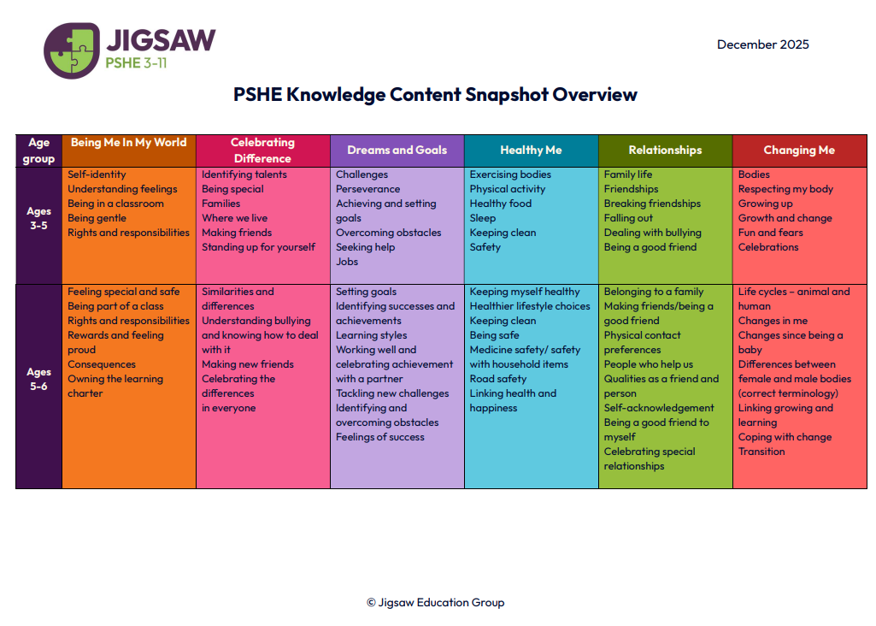
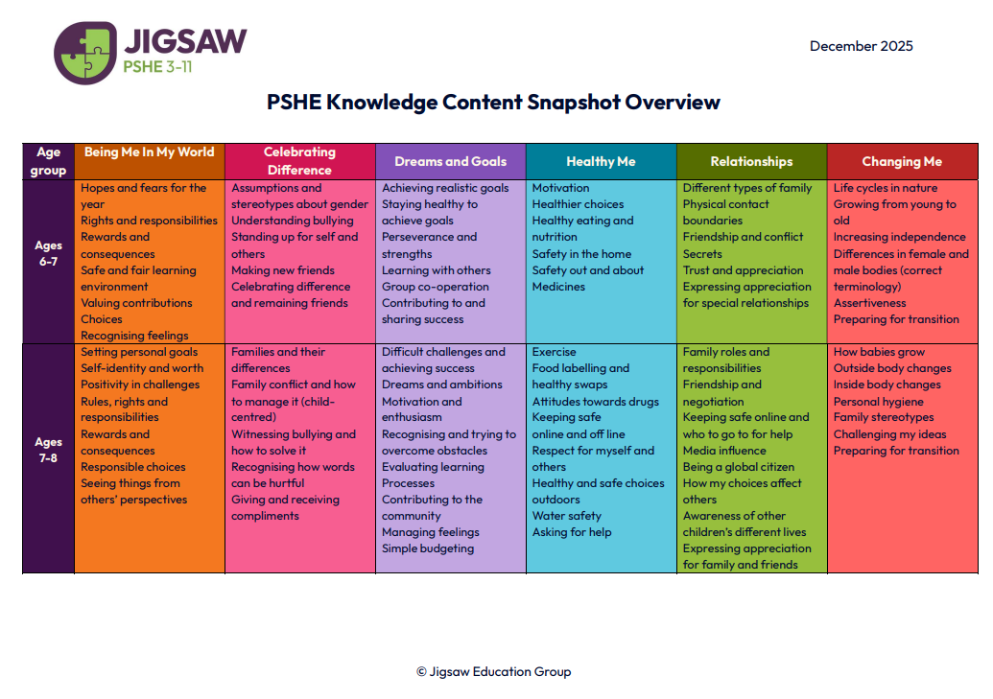
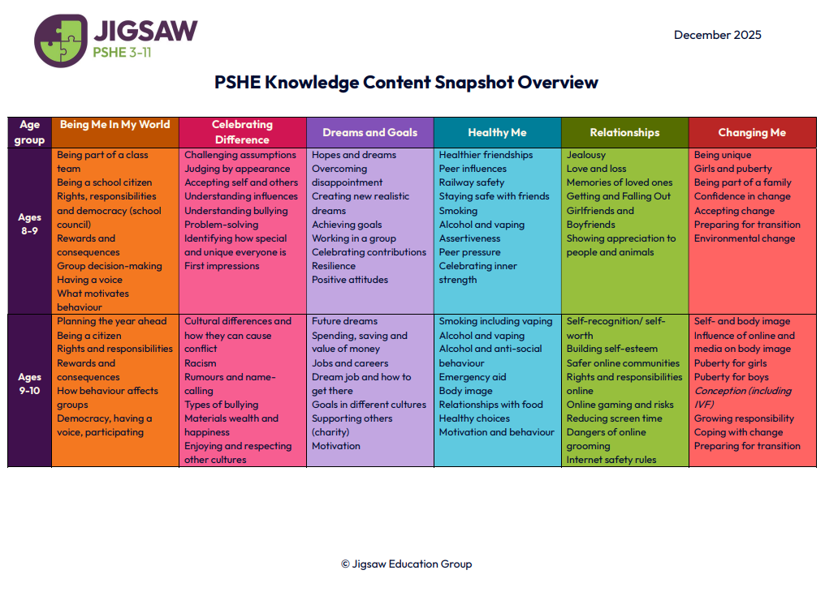

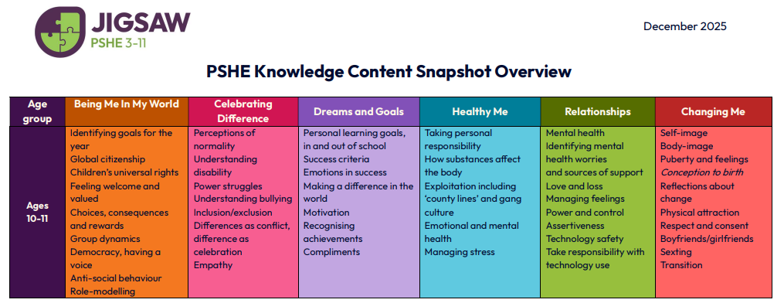

Appendix B: Sample of resources from: Being Me in my World Year 1

A sample of the slides the children will see:

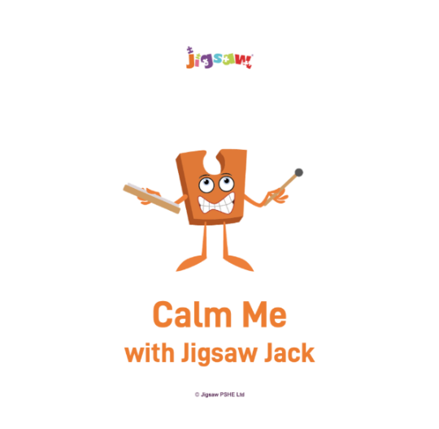


A sample of the planning and script the teaching staff will use:

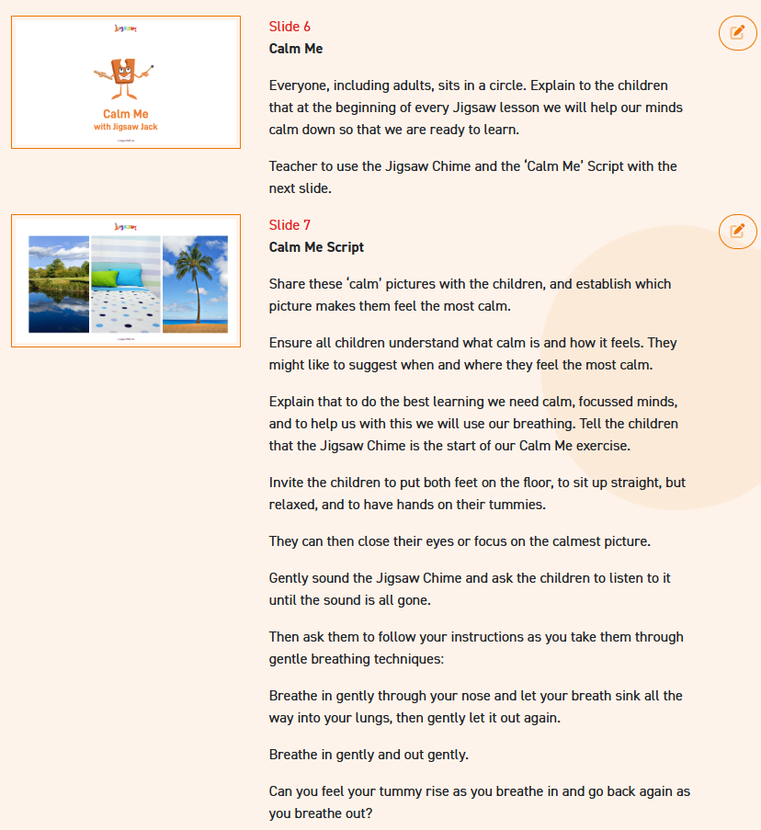

A sample of some resources that will be used during lessons:

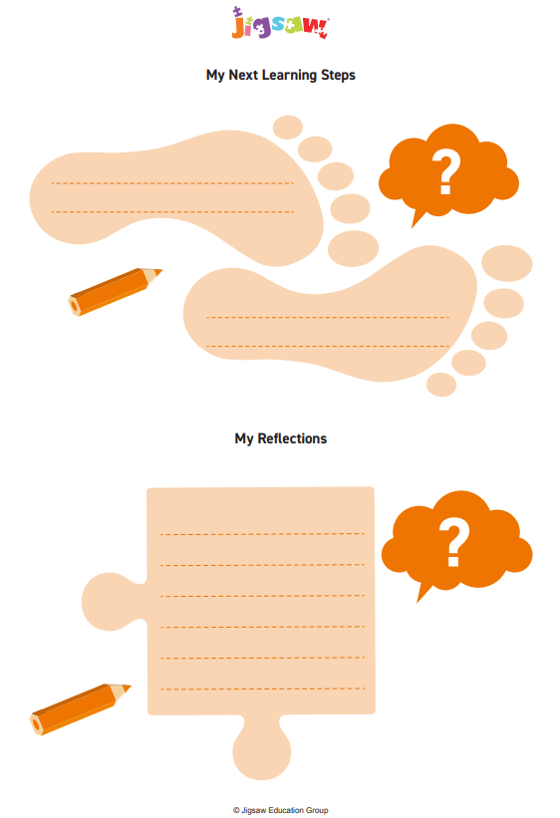
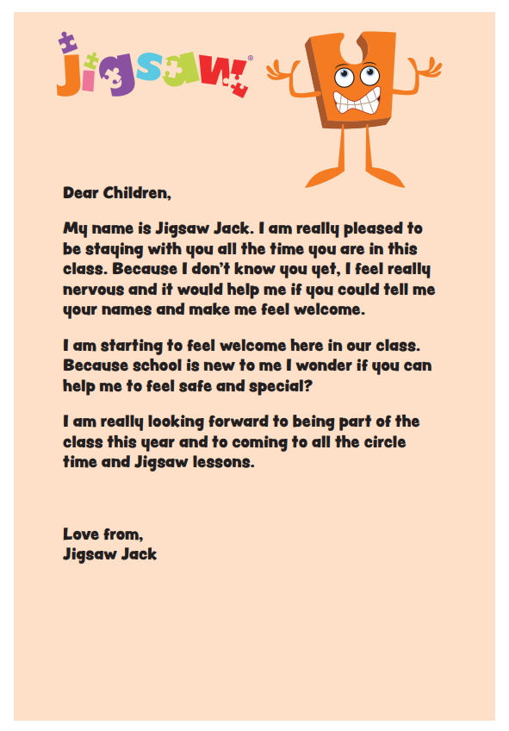

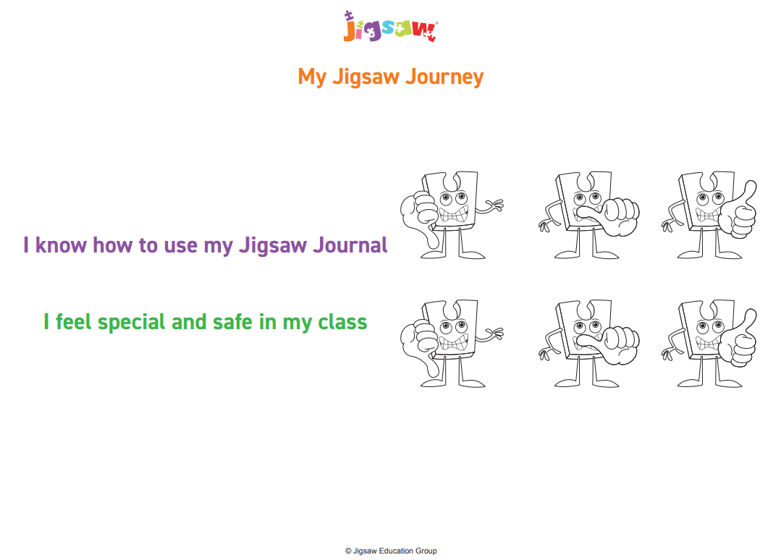

Appendix C: Parent/Carer form: Withdrawal from sex education within RSHE

If you would like your child to be withdrawn from sex education as part of RSHE please complete the form below and return to your child’s class teacher
Student Name: |  |  |  |  | Class:
Parent/Carer Name: |  |  |  |  | Date:
Please give your reason for withdrawing from sex education within relationships and sex education
Any other information you would like school to consider:
Parent/Carer Signature:
THIS SECTION TO BE COMPLETED BY SCHOOL: |  |  |  | Date:
Tick as appropriate:  - Discussion with parent about withdrawal |  | Agreed actions from discussions with parents:
- Sample lessons plans and resources shared with parent/ carers
- Relevant staff made aware of the withdrawal (Class teachers, support staff, DSL)
Staff Signature:

